**40. helm package**

--- **note** - you will learn how to package your chart so that it can be distributed or shared through repositories. It can be used to install the software across environments, testing, staging production through our CI CD pipelines as well.

--- We will learn how to share different versions of a chart using chart repos in a section later.

--- tree

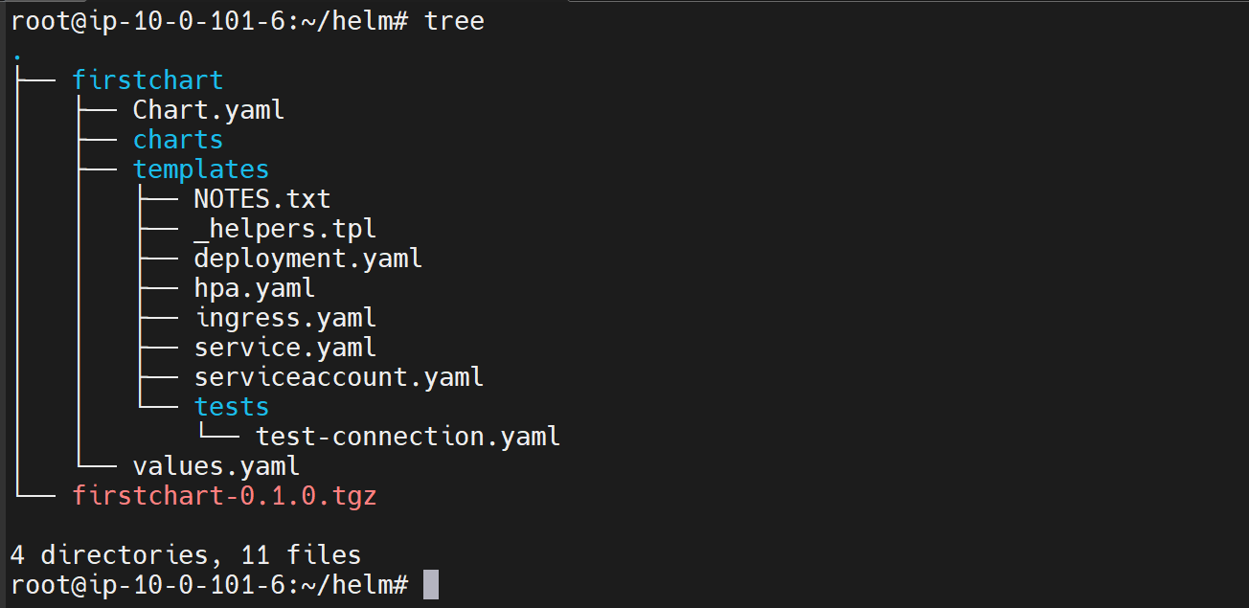

**# Package the chart**

--- helm package firstchart

**# Pull the latest dependencies and package it.**

--- helm package firstchart -u

--- **note** - If this chart depends on other charts, it will pull the latest versions of all those charts puts them under this charts folder before the packaging is done.